34.22: a) 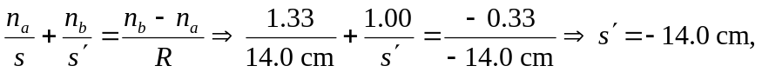so the fish appears to be at the center of the bowl.
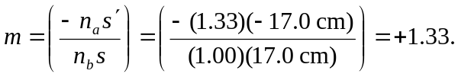
b) 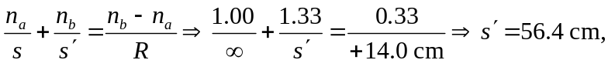which is outside the bowl.

